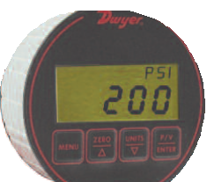3
[76.20]
2-3/8 [60.45]
1-5/8 [40.39]

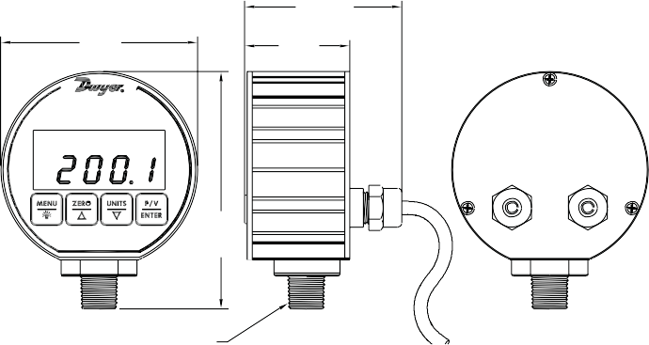

3-5/8 [91.39]

1/4 NPT

